PROBABILITY

Chance is a possibility of something happening.
Examples:
- Is it possible that we observe a black colour sun?
Answer: It is not possible to observe a black colour sun. The chance of this happening is zero.
- Is it possible that if today is a Monday, tomorrow is a Tuesday?
Answer: Definitely, it is possible. There is a 100 % chance that tomorrow is a Tuesday if it is a Monday today.
- Is it possible that we have a pizza for dinner?
Answer: It may or may not be possible, there is some chance. We may not be absolutely sure about having a pizza for dinner.

Observation:
Example 1 and example 2 had a clear possibility of occurrence. However, example 3 had an unclear possibility of occurrence.

The term Probability
When a chance takes us to a situation where the outcome cannot be predicted exactly (i.e. there is an unclear possibility of occurrence), Probability is used to quantify the variability in the outcome.

What is Probability?
By Probability, we measure the likelihood of an event in which we are interested.

What is the Likelihood of an event?
The Likelihood of an event is the frequency with which the event may occur.

Uses of Probability
Probability can be used to:

Describe the frequency of occurrence
When we want to know the chance of the occurrence of an outcome based on the number of times it has occurred, we make use of probability to calculate the frequency with which the event has occurred.
Example: Suppose we have a coin which is tossed ten times. This activity results into 6 heads and 4 tails. What is a chance that the head will appear in the next toss of the coin?
It can be inferred from this example that:
- The coin was tossed repeatedly.
- We can calculate the likelihood of having a head in the subsequent toss by having a knowledge of the total number of times the head has appeared in the previous toss.

Describe a subjective belief
The Probability can be used to understand the uncertainty which is associated with a certain belief.
Example: A scholar asserted that the Poem A and Poem B were written by the same Poet, with a 95% belief.
It can be inferred from this example that:
- The assertion conveys a belief, but not in terms of frequency since the subject (composing Poem A and Poem B) is a one-time event.
Note: In this course, we will use probability to describe the frequency of occurrence. Use of probability to describe the subjective belief will be covered in the inferential statistics course.

Consider an activity (experiment) of tossing a coin 10 times. This activity results in heads and tails (outcomes).
How can we proceed when we want to calculate "the chance of getting head more than the number of times the tail has appeared."
In order to answer questions of this kind, it is essential to understand the frequency with which each value (outcome) occurred.
The activity (experiment), results of activity (outcomes) and the frequency/likelihood with which the values (outcomes) may occur can be described using a Probabilistic Model.

Probabilistic Model
The probabilistic model is a generic structure which describes the random outcomes of an activity.

This model helps assign the likelihood of occurrence to a collection (set) of the random outcomes.

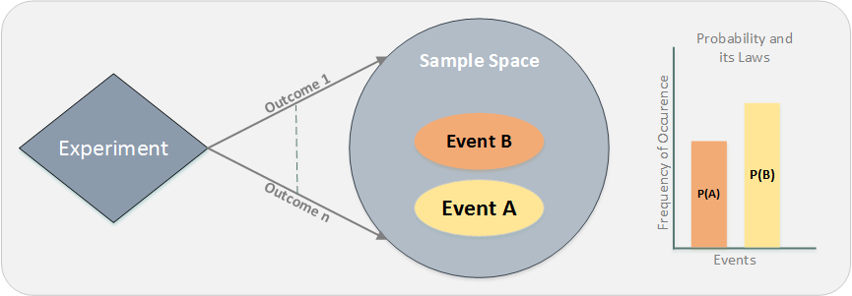
Source: Bertsekas Dimitri P. and Tsitsiklis John N. (Massachusetts Institute of Technology), Introduction to Probability. Athena Scientific, Belmont, Massachusetts: 2002

The process of observation of an activity is termed as an experiment.
The results of an observation are termed as outcomes of the Experiment.
The events for which we cannot calculate the outcomes, those experiments are called random experiments.

Examples:
Rolling a die
Tossing a coin
Drawing a card from the deck

Sample Space is the set of all the possible outcomes of a random experiment. It can be of two types which are as follows:

Continuous sample space
Example: Value of stock for a company can be between $15 and $25 = {15.01, 15.02, …,24.98, 24.99, 25}

Discrete sample space
Example: Number of people attending the meeting can be between 10 and 20 = {10, 11, 12,…,20}

If we narrow down our focus to one particular outcome or a set of some outcomes from the entire sample space it is termed as an Event

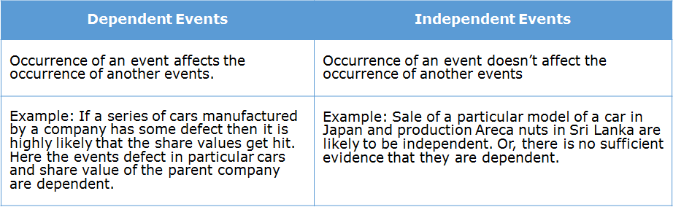

Meta-Phrasing
Real-time activities are described in words. It is essential to translate the word statements into equivalent representations.
Meta-phrasing refers to literal translation. Meta-phrasing involves word by word and line by line translation without loss of information.
Sets and Venn diagrams facilitate the meta-phrasing of the real-time experiment (described as word problems) to a mathematical model.
- Sets help translate the problems into mathematical representations.
- Venn diagrams help represent the Sets graphically.

Set Theory
A Set is a collection of distinct objects/elements. It is a collection of all possible outcomes.
The Sets help translate the problems to mathematical representations using set notations.
- If a set contains finite no. of elements (x1,x2,x3) it can be represented as S={x1,x2,x3}
  - Example: Set of all possible outcomes of a die roll S={1,2,3,4,5,6 }
- If a set contains infinite no. of elements (x1,x2,x3,…..) it can be represented as S={x1,x2,x3,…..}
  - Example: Set of all possible positive real numbers S={0,0.01,1,1.5,2,……}

ntersection: The intersection of two sets A and B is represented as A ∩ B
Union: The union of two sets A and B is represented as A ∪ B
Complement: The complement of Set A is represented as A

Difference: The difference of Set A and B is represented as A — B
Symmetric Difference: The symmetric difference of Set A and B is represented as A Δ B
Scenario: Let us consider a random experiment with some outcomes.
Event A and Event B are two amongst the many possible outcomes of the experiment.
How do we represent that Event A has not occurred: A
How do we represent that both Event A and Event B have occurred together: A ∩ B
How do we represent that either Event A or Event B or both have occurred: A ∪ B
How do we represent that both Event A and Event B did not occur together: A ∩ B
How do we represent that Event A has not occurred and event B has occurred: A ∩ B
How do we represent that all Event A is Event B but vice versa is not true: A ⊂ B

Venn Diagrams
Venn diagrams are used to represent Sets graphically.
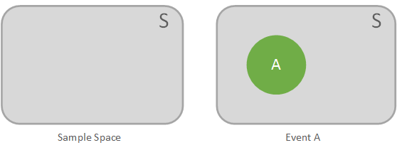

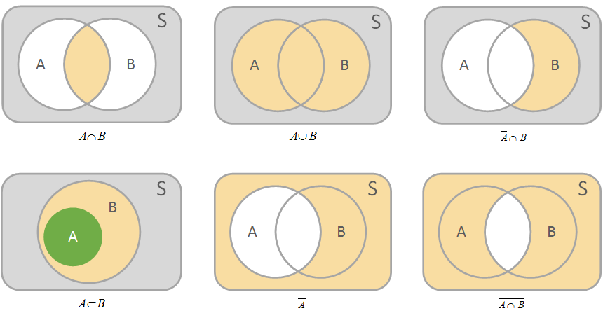

Introduction - Counting Techniques
Let's understand something in the context of a random experiment. For random experiments, it might be required for us to count the possible number of outcomes.
Now in order to count the possible number of outcomes, the simplest way to do that is to list all the possible outcomes of the given experiment.
However, for certain applied problems if the outcomes are too many in number it is not possible to list out all the possible outcomes.
For applied problems where the count of possible outcomes is essential and listing out all possible outcomes is not feasible we adopt sophisticated counting techniques.
Some of these commonly used techniques are:
- Product Rule
- Sum Rule
- Combinations
- Permutations

Product Rule

Consider a 3 stage experiment where stage A has 4 choices, stage B has 2 choices and stage C has 3 choices.
Let us try to find out the number of ways in which we can complete the experiment.
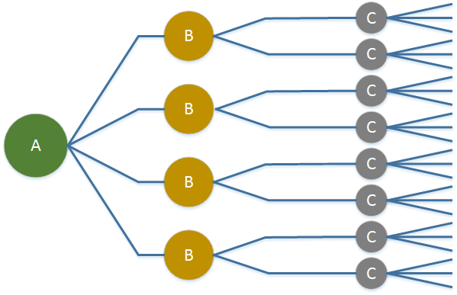

Total ways to complete the experiment = 4×2×3 i.e. (#Choices in stage A) × (#Choices in stage B) × (#Choices in Stage C)

Scenario: Consider stocks in the banking and automotive sectors.
- Stocks(Bank) = {Bank1, Bank2, Bank3}
- Stocks(Auto) = {Auto1, Auto2, Auto3, Auto4}
Let's take an example where an investor is interested in investing in both banking AND automotive sectors. The investor decides to go for one from each sector. How many different ways are there in which he can invest?

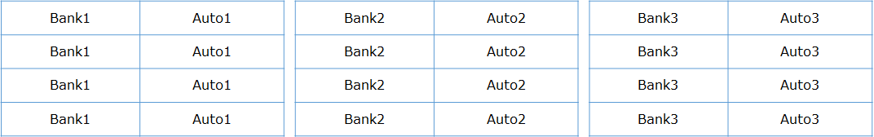

Total possible ways to make this investment is 3 × 4 = 12 i.e. (No. of bank stocks) × (No. of automotive stocks)

Scenario: Consider stocks in the banking and automotive sectors.
- Stocks(Bank) = {Bank1, Bank2, Bank3}
- Stocks(Auto) = {Auto1, Auto2, Auto3, Auto4}
If an investor likes to invest in either banking OR automotive stocks then how many total possible ways can he invest?
Total possibilities to invest in either banking OR automotive stock is 3 + 4 =7
The investor has to make a single choice from all the stocks added together,
i.e. (Total number of Banking stocks + Total number of Automotive stocks)

Combination

Scenario: Consider stocks of the automotive sector.
- Stocks(Auto) = {Auto1, Auto2, Auto3, Auto4} If an Investor wants to invest in 2 automotive stocks, in how many possible ways can he invest?
Total possible ways to invest are:

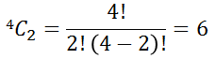

n - Total number of automotive stocks.
r - Number of stocks the investor wants to invest in.
The combination can be computed using the command comb(n,r) in Python (from scipy library) as shown below. For more details about comb function please click here.

Scenario: Now let's understand by another example. Let's suppose we have an urn which contains 3 red balls and 4 green balls. We are interested in calculating the number of ways in which we can select 2 red balls and 2 green balls.
Note: We cannot replace the balls i.e. Replacement not allowed.
Solution:
Ways to choose 2 red balls from 3 red balls is
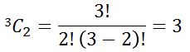

Ways to choose 2 green balls from 4 green balls is

So total ways to choose 2 red and 2 green balls = 3C2 x 4C2 = 3 x 6 = 18
Scenario: An urn contains 3 identical red balls and 4 identical green balls. In how many ways can we choose 2 red balls and 2 green balls.
Note: Replacement allowed.
Solution:
Ways to choose the 1st red ball from 3 red balls is
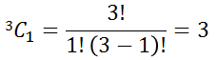

Ways to choose the 2nd red ball from 3 red balls is

Ways to choose the 1st green ball from 4 green balls is
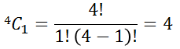

Ways to choose the 2nd red ball from 4 green balls is

Permutation

Scenario: Let's understand permutations by considering an example of an investor who wants to invest in 2 automotive stocks Auto1 and Auto2.
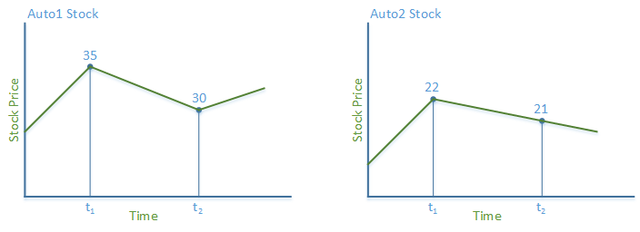
Case 1: Investor invests in Auto1 stock at t1 and Auto2 stock at t2 – Total cost incurred = 35+21 = $56
Case 2: Investor invests in Auto2 stock at t1 and Auto1 stock at t2 – Total cost incurred= 22+30 = $52
Observation: Case 2 is profitable. So investing in Auto2 first and then in Auto1 stock would be preferred against Auto1 first and Auto2 later. So the order is important.

Permutation deals with Order/Sequence.
Scenario: Consider stocks of the banking sector.
- Stock(Bank) = {Bank1, Bank2, Bank3}
If an investor wants to invest in 2 banking stocks out of the available 3 banking stocks, how many ways can he invest if ordered one at a time?
Total possible ways to make this investment is =
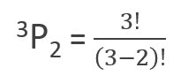

Scenario: Consider 3 distinct letters A, B and C. How many ways can these letters be arranged to have a 3 letter word.
Note: Repetition not allowed.
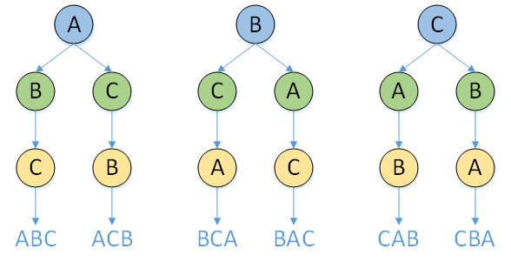
Solution:

In order to have a 3 letter word, 3 distinct letters can be arranged in 3P3=6 ways.

Scenario: Consider 3 distinct letters A,B and C. How many ways can 2 of these letters be arranged to have a 2 letter word.
Note: Repetition (Replacement) allowed
Solution:
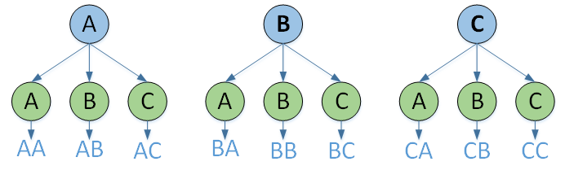

3 choices for each of the 2 selections are available when repetition is allowed and the order is significant.
So, total ways for this arrangement is 32 i.e. #Choices#Selections
Scenario: Consider 3 letters A, A and B. How many distinct ways can these letters be arranged to have a 3 letter word.
Note: Letter A is repeated twice.
Solution:
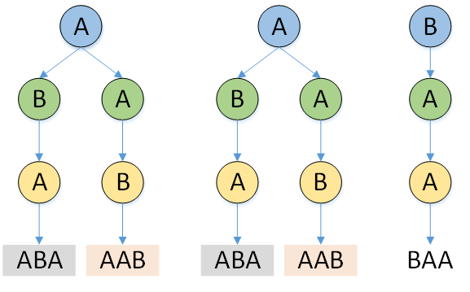

Distinct Words: ABA, AAB, BAA
Total distinct ways to arrange three letters to have a distinct 3 letter word is given by:
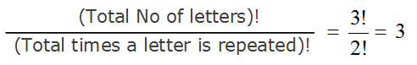

Introduction - Probability

Consider a random experiment with a finite sample space S.
Assignment of a real number to each event of the sample space is known as a probability measure that depicts the likelihood of occurrence of the Event.
Suppose a random experiment is repeated n times.
If the Event A occurs n times, then the probability of the Event A is given as P(A) = n(A)/n
where P(A) is a real number where n > 0
n(A) is the number of times event A has occurred.

Axioms
For a Finite Sample Space S, Consider an Event A.
The probability P(A) which is a real number assigned to the Event A must follow the below axioms :
- P(A) >= 0
- P(S) = 1
- If event A and Event B are mutually exclusive then,
P (A U B) = P(A) + P(B) , (A ∩ B ) = ∅

Elementary properties
Using the axioms the following properties of probability can be obtained:
- P ( A ) = 1 - P (A)
- P (∅) = 0
- P(A) < P(B) if A ⊂ B
- P(A) <= 1
- P(A U B) = P(A) + P(B) - P(A ∩ B)

Computing Probability
Scenario: Let's try to understand computing probability by taking an example of a box having 3 red balls, 2 blue balls and 1 green ball. Let's take one ball randomly. What would be the probability that the selected ball will be a blue ball?
Solution:
Total possible outcomes = Total number of balls = 3+2+1=6
Total ways a blue ball can be drawn = 2C1 = 2
The probability of drawing a blue ball =
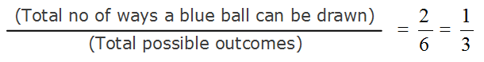

Scenario: Let's try to compute the probability of a fair die which is rolled 12 times. We observed that the number 4 turned up 5 times.
Now, what would be the probability of the number 4 being rolled for the given experiment?
Solution:
Total possible outcomes = 12 (Total number of times the die is rolled)
Number of times ‘4’ appeared = 5
The probability of number 4 being rolled =

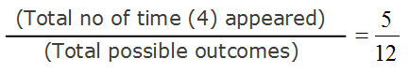

Conditional Probability
Conditional Probability is used to determine the likelihood of an event when a partial information about the event is known.
Examples:
- In an experiment of rolling a die, the die is rolled twice. It was observed that the sum of the outcomes was even. What is the chance that the first outcome was 2?
- In an experiment where a word is to be guessed. It was observed that the first letter of the word is ‘A’. What is the chance that the second letter is ‘b’?
Observation: In the above examples, what we have available is the partial information about the outcome of an experiment. In example 1, the sum is given as even and in example 2, the first letter is given.

Scenario: In an experiment of rolling a die, what is the likelihood that the outcome is 2, given that the outcome is even?
Consider a fair roll of a die i.e. all the outcomes of an experiment have an equal probability of occurrence = 1/6.
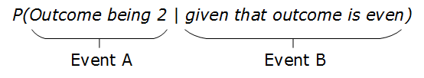
From the previous example :
It is given that the outcome is even (Event B)– so possible values are 2,4,6. Therefore the total number of elements for Event B =3
Event A can take any ONE value amongst 2,4,6. Therefore the total number of elements for Event A=1 So,
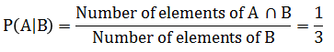

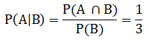

Conditional probability is undefined if the conditioning event has zero probability i.e. P(B)>0 is mandatory.

Consider a retailer procures bread from 3 different suppliers 40% from S1, 35% from S2 and 25% from S3.
It was found that 5% of bread supplied by S1, 2% supplied by S2 and 3% supplied by S3 are defective.
No other supplier is supplying bread - exhaustive
All suppliers are different – mutually exclusive
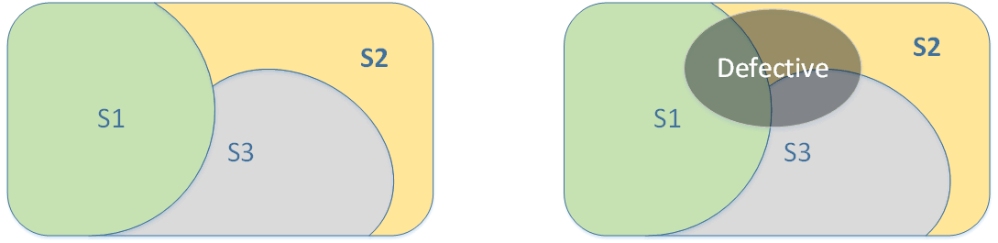

What is the possibility of a customer picking a defective bread?
What is the possibility that a selected defective bread is supplied by S2?

To visualize,

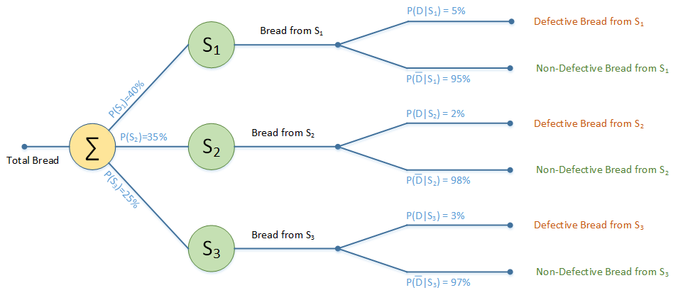

Extending Conditional Probability
f we have an event let's say D, in which a customer picks a defective bread, what would be the probability of finding a defective bread?
P(D) = P(S1)P(D|S1)+P(S2)P(D|S2)+P(S3)P(D|S3)
=(0.4×0.05)+(0.35×0.02)+(0.25×0.03)
= 0.0345
In general for ‘n’ suppliers
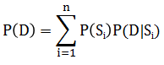

How would we calculate the probability of the event where a selected defective bread is supplied by S2?
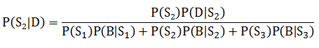

In general, the probability that the defective bread supplied by supplier ‘k’ (among ‘n’ suppliers, 1≤k≤n) is
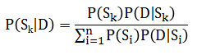

For Event A and Event B,
P (A ∩ B) = P(A)P(B|A) if P(A) ≠ 0
P (A ∩ B) = P(B)P(A|B) if P(B) ≠ 0
Bayes Theorem gives a relation between P(A|B) as

